## **Geopaths Scoring and Leaderboard Application - Administrator’s Guide**

**Version 1.0**

### **Description regarding this application:**

This application will allow a user to register, score, and track (on a public leaderboard) the Clemson geopath activity forms that they complete. Here are some notes about using this application.

* Users must have a Clemson ID and an @clemson g.edu email address. The application will not accept IDs that do not belong to g.clemson.edu email pool.
* Users will only have to register once the first time they access an activity form. After the user registers once they will no longer see the registration page unless they are removed from the leaderboard table.
* If a user fills out an activity form which they previously completed the new answers will overwrite the old answers from the previous entry. Even if all the new answers are incorrect they will be used to tally the user’s score.

### Registration Form:

The registration page will appear for any user that attempts to go to one of the geopath activity forms, but hasn’t yet added their name to the leaderboard score table. After a user registers once they will no longer be directed to this page when visiting any other activity form they wish to complete. The registration form appears as the picture below.

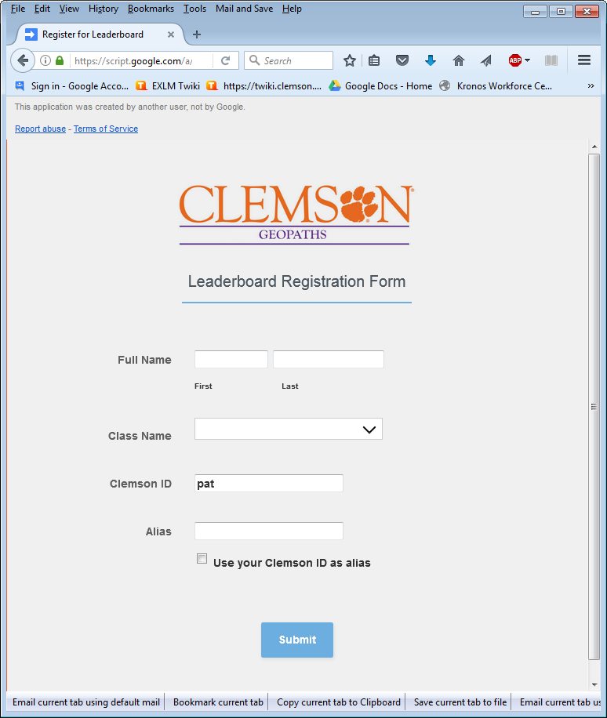

When a user fills out a registration form he/she must fill out all text fields.

* Full Name - You must supply both a first and last name.
* Class Name - You may select multiple class instructors if you are attending more than one or you may select none if you are not currently taking any classes from listed instructors.
* The Clemson ID field will always show your Clemson ID.This field cannot be modified.
* The Alias field allows you to specify what name you want to represent you within the leaderboard table. Note: The checkbox below allows you to use your Clemson ID as the alias, but a warning will display indicating that you are allowing people to see your Clemson ID within the leaderboard table.

Once all the fields are filled, the user can submit the registration form and proceed to the Geopaths activity form.

### Leaderboard Table:

You can access the leaderboard at the following URL: <https://script.google.com/a/macros/g.clemson.edu/s/AKfycbxGCG77PmiMNJoObz_-UJS-jJqdQ4JoKvHDPs22r8wIBJRBOAbl/exec>

This link has been shared within Google Apps to be viewable by anyone.

### **Administrator’s Information:**

The administrator ID that allows an administrator to make changes to any of the forms or tables is [clemsongeopaths@g.clemson.edu](mailto:clemsongeopaths@g.clemson.edu). You will need to login to google drive under that email address in order to modify any application content.

**Important Note:** When logged into Google Drive as the administration ID, you will not be able to register for the leaderboard or fill out an activity form as a normal user. You will need to use a different ID and email address if you want to imitate an actual user accessing the application.

The following spreadsheet files are used explicitly for this application:

Spreadsheet:

* **Form Links table** - This table lists information that is needed by the application.
  + Location: My Drive\Forms List and Course List\Form Links
  + URL: <https://docs.google.com/spreadsheets/d/1tEt2zkoUZKth8s1d98JRGWDgX0r5rgR32uTjQ2kpFso/edit#gid=0>

A description for each column is listed below:

* + Column “Class” - Lists all the instructor names associated with these activities. This column is used with the registration and leaderboard pages. If you want to add another classname just append it to the end of the column.
  + Column “ColumnKey” - Is used to specify which column in the Leaderboard table contains the score for the activity associated with it. For example: For the activity, “Cemetery Weathering” The Column Key is “H”. When you look in column H of the Leaderboard table you will see each individual's score specifically for that activity.
  + Column “Forms” - The filename of the activity form.
  + Column “Activity” - This is the activity name of the activity form. Each of these names should be similar to the Forms file name, but all spaces and special characters should be excluded from the name.
  + Column “ActivityLink” - is the URL to the activity form. It’s used by the registration page.
  + Column “SheetID” - This is the ID that google uses to identify files within Google Drive. These IDs are of all the spreadsheets that get filled out when someone submits an activity form.
* **Leaderboard table** - This table keeps track of all the participants scores and adds them up for a total score.
  + Location: My Drive\Forms List and Course List\Leaderboard Table
  + URL: <https://docs.google.com/spreadsheets/d/17UZTk8WdPCZom7HTg8NtPAf5oVVLVfgdIZSP-yfKDVU/edit#gid=0>

A description for each column is listed below:

* + UserID - The user’s Clemson userID
  + Alias - Is the name the user chose to represent their place in the leaderboard.
  + FirstName - User’s first name.
  + LastName - User’s Last name.
  + Class - All the class instructors the user is currently attending.
  + TotalScore- The tally of all the activity scores the user has achieved.
  + [activityname] - The rest of the columns are activity names. Under each activity name will be the scores of the users that have taken that specific activity form questionnaire.

### 

### 

### **Guide to Administrative Tasks**

#### **I. Using the Administrator Manager Panel**

You can access the admin panel through the following URL:

<https://script.google.com/a/macros/g.clemson.edu/s/AKfycbzMcNMVzsTtJ70GbYqhVr26GRhyD22JA_RF8Phz77akL6HfJxvM/exec>

You must be logged in as the administration ID in order to load this panel. Otherwise an error will occur.

The administrator panel has several functions associated with it (See the picture below to see which numbers correspond with which function):

1. Archive button for each activity that allows you to archive current activity spreadsheets to an archive folder.
2. Calculate button for each activity that allows you to re-scrore all the users’ answers for the given activity. If there were users that were not scored then this function will also score those users too.
3. Activity checkbox allows an admin to enable or disable the triggers that allow real time scoring for each user that submits an activity form. An unchecked box will allow users to submit answers through the form but those answers will not be graded. If the box is checked then all answers (except the answer key answers) will be graded immediately after they are submitted.
4. Allows you to see the status of the activity.
   1. “**ACTIVE**” means the activity will score users immediately after submitting their answers.
   2. “**INACTIVE**” means the activity sheet will still store a user’s answers after submitting the form, but those answers will not be scored or added to the leaderboard.
   3. “**PROCESSING**” means the application is currently running an admin function. The activity form is unavailable at this time.

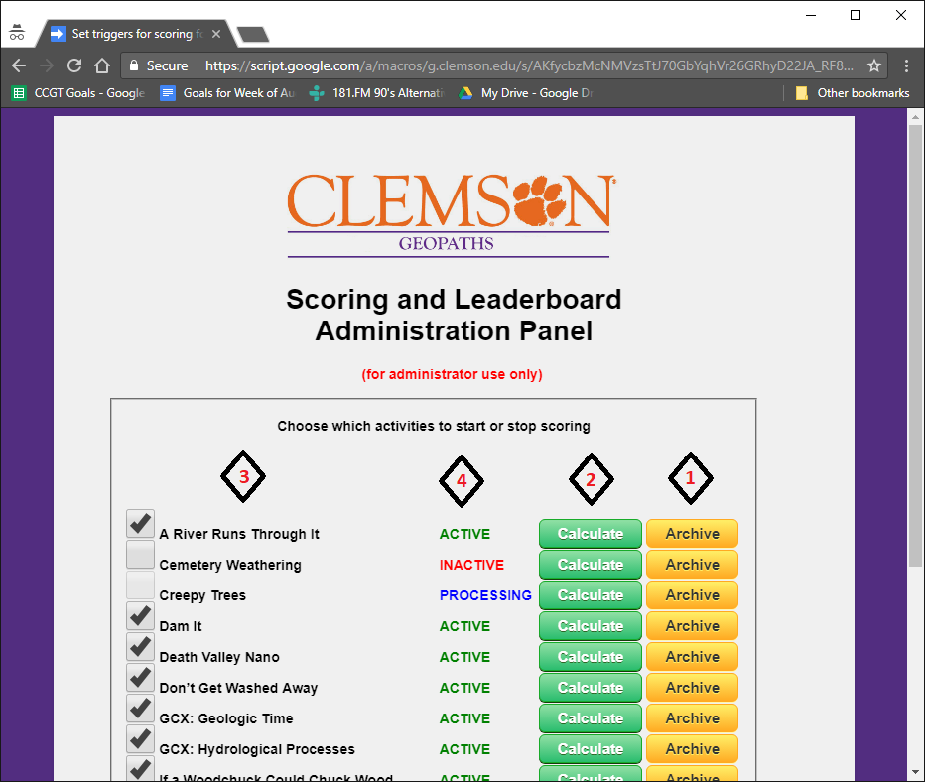

#### 

#### **II. Creating answer key for each activity form**

In order for scores to be calculated, each activity must have an answer key that can be used to grade each user. After an answer key is submitted it will be highlighted within the activity spreadsheet with a cyan background.

If you submit an answer key and one already exists then the older answer key will be replaced with the answer key just submitted. If a user submits answers from a form and there is no answer key defined for that form then the user’s answers will not be scored or added to the leaderboard. You will be able to score all unscored answers using the Administrator Manager Panel. *Please see “Using the Administrator Manager Panel” in a section above.*

**Steps required to create an answer key.**

1. You must login to Google Drive under the administrator ID: [clemsongeopaths@g.clemson.edu](mailto:clemsongeopaths@g.clemson.edu)
2. Open the activity form (in view not edit perspective) for which you’d like to create an answer key.
3. Fill out the form with the correct answers. The “first and last name” field on the form can be anything you’d like. Usually, you’ll want to put “answer key” so you can identify it easier. There are 3 types of special answers you can declare which will allow answers from the users to be interpreted in a specific way. You can specify these special types of answers in the answer field when you’re creating the answer key.

**[text]** - This parameter can be used for answers that require students to complete a fill in the blank type of answer. With the “[text]” parameter specified in the answer field a user can type anything in the field and it will be considered correct. If the field is blank then the answer will be considered incorrect. In the answer key you can also put the correct answer after you specify this parameter. This is just for your own reference and has no meaning to the answer key.

Example for answer key field: **[text] Large, rounded cobbles in the area**

**[score #max]** - This parameter will allow a user to type a number (will be converted to integer) and that number will be added to the users total score for the activity. The #max parm allows the administrator to specify a maximum score the user can enter. If the users enters a value larger than the maximum score then the score will be changed to 0.

Example for answer key field: **[score 300]**

**[range #low #high]** - This parameter will allow a user to enter a number. If the number is within the range of numbers you have specified then the user will be given credit for the answer. For a valid number a user shouldn't include any prepending text or symbols (such as $ or %) It's fine for the user to put those symbols after the number.

Example 1 for answer key: **[range 10.5 13]**. Correct user answers would include 10.5, 11, 12.9%, and 13 $.

Example 2 for answer key field: **[range 20 20]**. Correct user answers would include only 20 or 20% or 20$.

1. Once the answer key fields are filled out submit the form, and the answer key should appear within the activity spreadsheet highlighted in cyan.

#### 

#### **III. Creating a new activity form that will be recognized by the application.**

The following instructions will help you configure a new activity so that the “Scoring and Leaderboard Application” will utilize the new activity. You will need to be logged in as the **administrator ID** in order to complete this process.

**The following assumptions must be correct before the instructions for creating a new activity can be followed:**

* An activity form has been created and linked to a spreadsheet. This spreadsheet will be referred to as the “activity spreadsheet”. When creating a new activity form it is important that the activity spreadsheet follow these guidelines:
* The question headers within the activity spreadsheet that you wish to be scored **MUST** have a different background color other than white. It can be any color you want, but if you want the question to be scored it can’t be white. In the example picture below the color: “light orange 3” was used as the background color. It is recommended that you keep the colors consistent within each activity form for the sake of clarity.

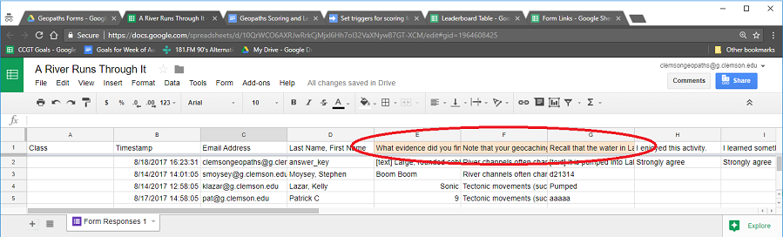

* There must be a “Timestamp” and an “Email” header within the activity spreadsheet. The email column header **MUST** have the word “email” and the timestamp column **MUST** have the word “timestamp” (upper or lower case is ignored) in it. The application does a text search for these words in the headers. Other headers within the activity sheet should not use these words to prevent problems.

Once you’ve made sure that your activity spreadsheet meets the requirements above then you’re ready to set up a new activity form.

**Steps required to configure activity form to use Scoring application:**

1. Open up the **Form Links** spreadsheet. Should be located at <https://docs.google.com/spreadsheets/d/1tEt2zkoUZKth8s1d98JRGWDgX0r5rgR32uTjQ2kpFso/edit#gid=0>
2. Use the next blank row after the last activity and put the name of the activity form in the column with the header label “Forms” (3rd column). You ***can*** have spaces, quotations, or special characters in this name.
3. Copy the name from the “Forms” column you entered in the previous step and remove all spaces, special characters, and quotations. You may still use a mix of upper and lower case characters if you wish. Take this name and place it in the column with the header label “Activity”.

**Important Note:** because this name will be used within the URL link to the activity form this name should not be changed after it is put into production unless you also change the URL link to reflect the updated name.

1. Copy the URL link of the activity form and put it in the column with the header label “ActivityLink”. You want to make sure that the URL you copy is the one that allows you to view and interact with the form. Not the URL that allows you to edit the form.
2. Open up the activity spreadsheet linked to the activity form. Copy the spreadsheet ID that is included in the URL. This ID will be between two forward slashes

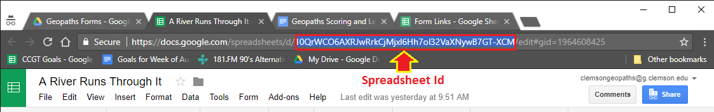

Paste the spreadsheet ID in the **Form Links** spreadsheet under the column with the header label “SheetID”.

1. Open the **Leaderboard** spreadsheet. Should be located at <https://docs.google.com/spreadsheets/d/17UZTk8WdPCZom7HTg8NtPAf5oVVLVfgdIZSP-yfKDVU/edit#gid=0>
2. In the **Leaderboard** spreadsheet find the first available column that has no header label or numbers in it. Get the column letter that represents that column and type it into the **Form Links** spreadsheet under the column header label “ColumnKey”.
3. In the **Form Links** spreadsheet copy the text that you used in Step 3 for the column header label “Activity”. Within the **Leaderboard** spreadsheet paste that text as a header under the column letter you used within step 7.

**For example:** In step 3 you pasted “CarolinaBayActivity” under the “Activity” column in the **Form Links** spreadsheet. In step 7 you typed the Letter “U” under the “ColumnKey” column in the **Form Links** spreadsheet. Now you will paste the “CarolinaBayActivity” in the first row of Column “U” in the **Leaderboard** spreadsheet.

1. Open the Administrator Manager Panel or if it is already open then refresh the panel in your browser. The URL is: <https://script.google.com/a/macros/g.clemson.edu/s/AKfycbzMcNMVzsTtJ70GbYqhVr26GRhyD22JA_RF8Phz77akL6HfJxvM/exec>

Your new activity name should appear at the bottom of the list of activities. If you are unfamiliar with this panel then please read the section: *“Using the Administrator Manager Panel” in the previous section*

1. You will want to turn on real time scoring by clicking on the empty checkbox next to your new activity. After a couple of seconds your status message next to the activity should change from “Inactive” to “Active”. This means your activity spreadsheet is ready to accept and score users’ responses.
2. If you haven’t created an answer key for your activity spreadsheet then please follow the procedure above called “*Creating answer key for each activity form*” for instructions on doing that.

#### **IV. Creating a link that users can use to access the new activity form.**

For all the activity forms there is only one URL that is used to access the registration page and form afterwards, but a query parameter with the correct activity name must be appended to the end of the URL.

The URL is: <https://script.google.com/a/macros/g.clemson.edu/s/AKfycbxGdIgUfkilrTuzaXEP5xNsYjlL4soytYjEFXguvm0e98TgxFE/exec>

By itself the URL will not work, but if you add a query parm in the form of “?a=<activityname>” then the URL will redirect the user, first to the registration page (if the user hasn’t registered yet), and then the appropriate activity form.

The <activityname> should be replaced with the text under the header “Activity” in the **Form Links** spreadsheet.

Example: The following URL will access the activity for “A River Runs Through It”

<https://script.google.com/a/macros/g.clemson.edu/s/AKfycbxGdIgUfkilrTuzaXEP5xNsYjlL4soytYjEFXguvm0e98TgxFE/exec?a=ariverrunsthroughit>

This is the link you will want to use for any users that want to access that activity.